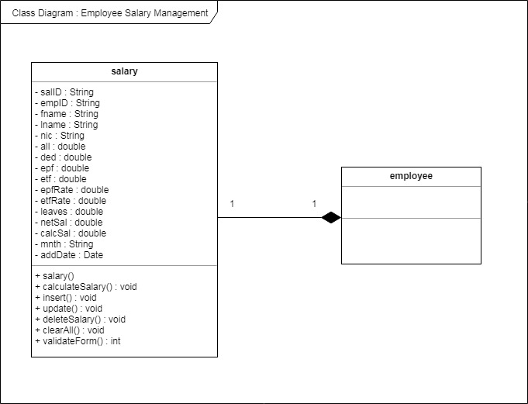

Class Diagram : Employee Salary Management

**salary salary**

- sallD : String - emplD : String - fname: String - Iname : String - nic : String - all: double - ded: double - epf: double - etf: double - epfRate : double - etfRate : double - leaves : double - netsal: double - calcSal : double - mnth : String - addDate : Date

**employee**

+ salary + calculate Salary(): void + insert(): void + update(): void + delete Salary : void + clearAll(): void + validateForm(): int